Name and Surname: SANTE
Address:
Postcode and City:
Country:
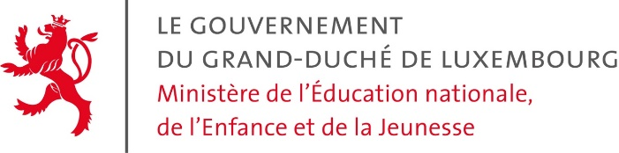
Department for the recognition of diplomas
L-2926 Luxembourg
Concern: Request for the recognition – Regulated profession in the field of healthcare
Dear Sir or Madam,
I hereby request, if possible, a recognition of the equivalence of the following diploma:
- Name of diploma:
- Date of receipt of diploma:
- Exhibition country of diploma:
Compared to the Luxembourgish diploma in one of the following professions of healthcare:

- Caretaker
- Nurse
- Anesthesist
- Pediatric nurse
- Psychiatric nurse
- Technical Medical Assistant
(RX, Surgery, Laboratory)
- Masseur
- Midwife
- Dietician
- Ergotherapist
- Laboratory Technician
- Masseur – Phisiotherapist
- Speech Therapist
- Orthoptist
- Podologue

I remain, dear Sir or Madam, with best regards.
Date:
……………………………………………...
Signature

The following documents are mandatory for the request:
- Curriculum vitae in which personal details as well as the date and place of birth, the educational background, the professional experience and any internships are listed in detail.
- Copy of a valid ID (ID-Card, passport or residence permit)
- Copy of diplomas / degrees ²
- Copy of work certificates in the social-educational field ²
- Transfer certificate of the tax, which came into force by law on 01.01.2015 with the introduction of additional taxpayers' money ¹

Explications:
(1) Amount of taxes:
Diplomas issued by the European Union: 75 €
Additional tax in the case of a compensation measure + 300 € (Adaptation internship / aptitude test)
The tax must be transferred to the following current account:
Banque et Caisse d’Épargne de l’État
IBAN : LU36 0019 5955 4436 2000
BIC/SWIFT : BCEELULL
Name of the beneficiary: Administration de l'Enregistrement et des Domaines
The registry administration and must be provided with the following message:
<Taxes reconnaissances de diplômes, MENJE, name of applicant, date>

Attention:
(1) The tax becomes due when the file is opened, but does not automatically guarantee the recognition of the equivalence of a diploma.
(2) Copies of documents from a country which is not a member of the European Union must be certified copies and be issued by a state-recognized authority.
If the documents are not in one of the three official languages (Luxembourgish, French or German), they must be translated into an official language by a translator certified by the Luxembourg legal entity.
Additional documents might be requested by letter.

