Name and surname: TECHN / BAC / BACTR
Address:
Postcode and City:
Country:
Email:

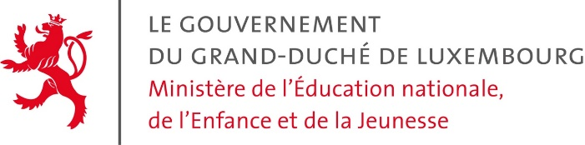
Department for the recognition of diplomas
L-2926 Luxembourg
Concern: Request for the recognition of a diploma
Dear Sir or Madam,
I hereby request, if possible, a recognition of the equivalence of my diploma:
- ……………………………………………………………………………………………………………………………………………
- Supported by my diploma: ......................................................................................................
Only third country and / or country whose maturity is acquired before 12 years of studies
Compared to the Luxembourgish diploma:
- Diplôme de technicien
- Diplôme de fin d’études secondaires générales
- Diplôme de fin d’études secondaires classiques
For the following reason:
- Continue my studies
- Go to work
- Other: …………………………………………………………………………………………………………………………………..
I remain, dear Sir or Madam, with best regards.
Date and Signature: …………………………………………………………………………………………
The following documents are mandatory for the request:
- Curriculum vitae in which personal details as well as the date and place of birth, the educational background, the professional experience and any Internships are listed in detail.
- Copy of a valid ID (ID-Card, passport or residence permit)
- Copy of diplomas / degrees ²
- Transfer certificate of the tax, which came into force by law on 01.01.2015 with the introduction of additional taxpayers' money ¹

For a baccalaureate obtained in a third country (countries that have not signed the Paris and / or Lisbon conventions on the mutual recognition of diplomas):
- Copy of a certificate / diploma attesting the successful completion of at least 3 years of graduate or university studies in an EU member state
- Proof of enrollment at an institute of higher or university studies in an EU Member State as well as the list of subjects examined at the baccalaureate / diploma of maturity
- Copy of a diploma awarded by an institute of higher education recognized by a third State, sanctioning a cycle of higher studies of at least 3 years ²
Also attach one of the following 3 pieces:
- A language certificate of B2 level in the Common European Framework of Reference for Languages, for the Luxembourgish, French or German language.
- An evidence that during 3 years of schooling Luxembourgish, French or German has been studied.
- A document certifying that Luxembourgish, French or German has been passed as an exam in High School.

Explications:
(1) Amount of taxes:
Diplomas issued by signatory countries of the Paris and Lisbon Conventions: 75 €
Diplomas issued by one of the non-signatory countries of the Pairs and Lisbon Conventions: 125 €
Diplomas issues by the IBO (International BAC): 125 €
The tax must be transferred to the following current account:
Banque et Caisse d’Épargne de l’État
IBAN : LU36 0019 5955 4436 2000
BIC/SWIFT : BCEELULL
Name of the beneficiary: Administration de l'Enregistrement et des Domaines
The registry administration and must be provided with the following message:
<Taxes reconnaissances de diplômes, MENJE, name of applicant, date>

Attention:
(1) The tax becomes due when the file is opened, but does not automatically guarantee the recognition of the equivalence of a diploma.
(2) Copies of documents from a country which is not a member of the European Union must be certified copies and be issued by a state-recognized authority.
If the documents are not in one of the three official languages (Luxembourgish, French or German), they must be translated into an official language by a translator certified by the Luxembourg legal entity.
Additional documents might be requested.

